EC2 instance with VPC and public subnet

Task : set up a VPC with an Internet gateway, create a public subnet, a private subnet make a route table connecting the Internet gateway and the subnets, and launch a Linux EC2 instance by using the above vpc and public subnet.

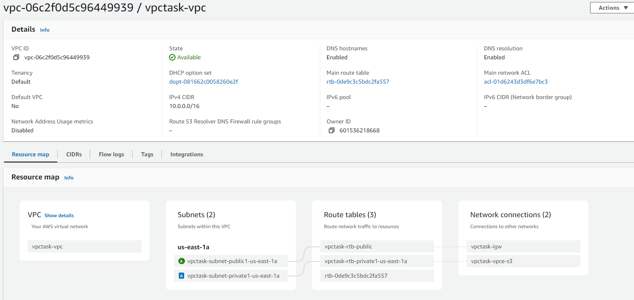

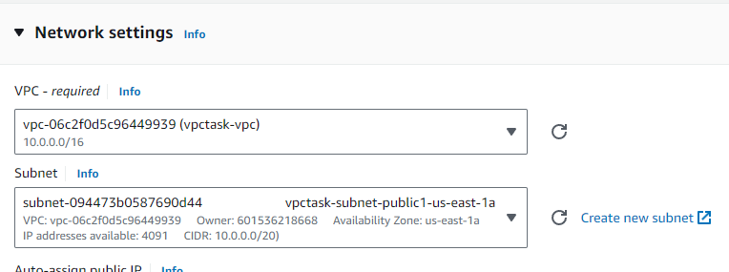

Instance is created with vpc created and used public subnet

